

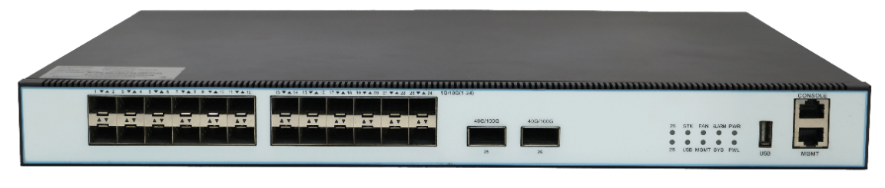

S5863-24X2C
L3 Managed Ethernet Switch

Product Overview
The S5863-24X2C is a Layer 3 switch with high-performance capabilities, offering full 10G access, 40G, and 100G uplink core routing. It is designed to meet the high-density and high-bandwidth requirements of next-generation enterprise networks, data centers, and metropolitan area networks. Additionally, it serves the needs of telecom network operators and can function at the aggregation or access layer of campus Ethernet networks. This device can also be used as a connection layer in data centers.
The S5863-24X2C switch features a comprehensive set of services, including Layer 2, Layer 3, MPLS, VXLAN, OAM/APS, and more, along with support for security, flow control, hardware-based NetFlow, and high-precision clock capabilities. The product includes an elastic stacking function, which allows multiple devices to be virtualized into a single logical entity. This not only facilitates the expansion of ports and switching capacity but also enables unified management, upgrades, and maintenance across devices.
To address the demands of large data traffic and non-blocking transmission in data centers, this switch provides robust caching capabilities and an advanced cache scheduling mechanism to maximize effective use of device cache capacity. It is tailored to meet the needs of high-density and high-bandwidth network applications in next-generation enterprise networks, data centers, and metropolitan area networks. The switch is versatile enough for use in network operator environments, campus Ethernet aggregation or access layers, data center access layers, and even as a core layer in small to medium-sized enterprises, offering comprehensive server access solutions for data centers.

Device Brief Information
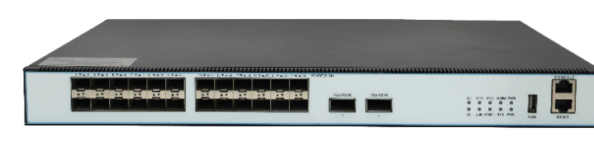  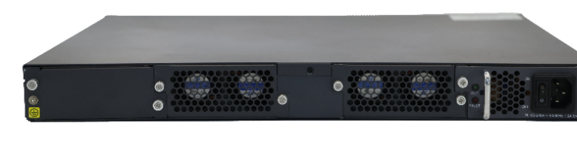 | S5863-24X2C  - 24*1000M Base-X SFP/10GE SFP+  - 2*40G QSFP ports/2*100G QSFP28  - 1+1 modular redundant power supply  - Two modular Fans  - Size: 440×320×44mm 19” Rack-mount  - AC: 100～240V; 47/63Hz

Key Features

Equipment Stability
- Support IPv4/IPv6 dual protocol stack platform based on Linux operating system
- Support multiple link redundancy and network redundancy protocols such as STP / RSTP / MSTP / ERPS / LACP

Carrier-level equipment stability
- Based on Linux operating system, support IPv4/IPv6 dual protocol stack platform
- Support multiple link redundancy and network redundancy protocols such as STP/RSTP/MSTP/ERPS/LACP

Stackable
- Support Combine the processing power of multiple switches into a single logical device.
- Support When a switch in the stack system fails, traffic can be automatically switched to other switches, network availability and redundancy.
- Support Stacking simplifies the management process. Administrators only need to manage one logical device.

Perfect safety mechanism
- Support ACL security filtering mechanism, which can provide security control functions based on MAC, IP, L4 port
- Support ARP attack automatic protection and user blocking functions
- Support DHCP attack automatic protection based on Mac Address and user blocking functions
- Support DHCP-snooping/IP-source-Guard/802.1X and other security features
- Support link protection functions such as BFD, FlexLink, LACP
- Support remote loop detection function
- Support remote user authentication based on Tacacs+, Radius, and Local user authentication

Powerful QoS capabilities
- Support port speed and flow speed limit function
- Support classification based on service flow and Qos flow control function
- Support queue scheduling algorithms such as SP/WRR/SP+WRR
- Support port-based and service flow-based mirroring functions

Enhanced multi-service capabilities
- Support DHCP Server and DHCP Relay

Rich routing protocol
- Support static route
- Support dynamic route such as RIP, OSPF, BGP,
- Support IPV4/IPV6 dual protocol stack, support RIPng、OSPFv3

Simple and easy-to-use network management function
- Support CLI based on RS232 serial port, Telnet and SSHv2
- Support WEB-based configure operation management, support SNMP V1/V2/V3
- Support remote upgrade or equipment through FTP and TFTP

Hardware Specifications
Attributes | S5863-24X2C
Port | 24*1000M Base-X SFP/10GE SFP+,  2*40G /100G QSFP28
Exchange Capacity | 880Gbps
Packet Forwarding Rate | 595.24Mpps
Memory and Storage | Memory: 1GB; Storage: 8GB
MAC Address | 32K
Packet Buffer | 72Mbit
Power | AC: 100～240V; 47/63Hz  DC: -40~-60V
Power Consumption | Idle ≤33W  Full load: ≤60W
Weight | ≤8.6kg (AC+AC)
Dimensions (W*H* D) | 440×390×44 (mm*mm*mm)
Environment | Working Temperature：-10℃～55℃  Storge temperature：-40℃～70℃  Relative Humidity: 5%~95%, non-condensing

Panel view

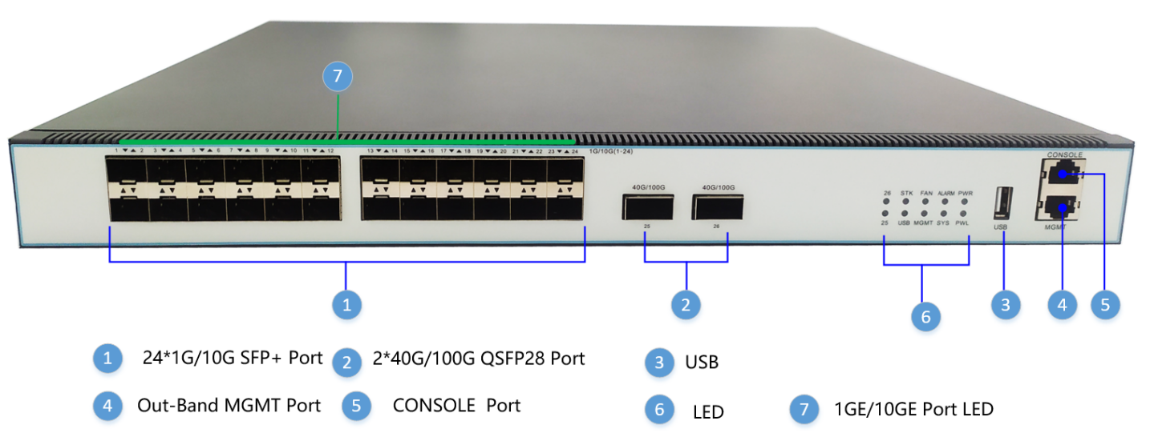
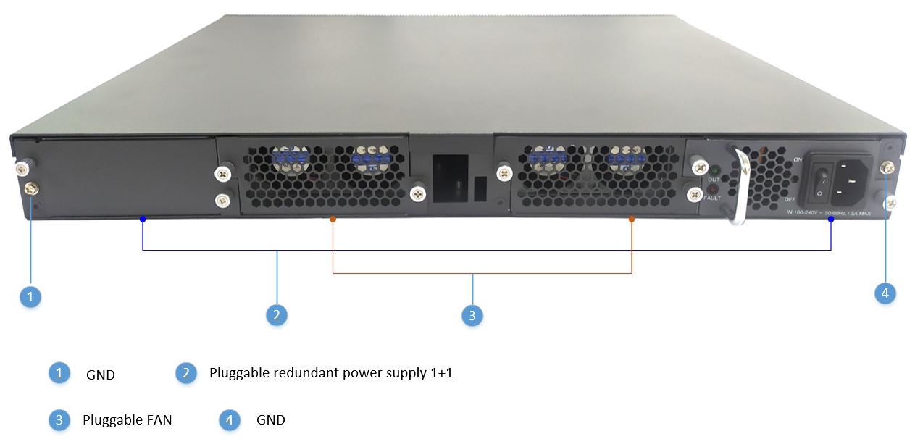
Label | Connector Type | Connector Description
40G/100G 1-2 | QSFP28 | Connect to external uplink equipment
1G/10GE 1-24 | SFP+ | Connect to external uplink equipment
USB | USB2.0/3.2 | Connecting peripherals for uploading and downloading configuration
CONSOLE | RJ45 | The software debug port
MGMT | RJ45 | The out-band management port

LED indicator
LEDs/Buttons | Color | Function | Description
PWR | Green | Power status | ON | The AC/DC power module is normal.(right)
PWR | Green | Power status | OFF | The AC/DC power module faulty or unavailable
PWL | Green | Power status | ON | The AC/DC power module is normal.(left)
PWL | Green | Power status | OFF | The AC/DC power module faulty or unavailable
ALARM | Red | Port status | ON | Critical alarms are reported for the card.
ALARM | Red | Port status | OFF | No critical alarm is reported for the card.
SYS | Green | System running status | Green OFF | The device is not running or power off.
SYS | Green | System running status | Green Flash | The device is running normally.
FAN | Green | Fan running status | ON | FAN is running normally.
FAN | Green | Fan running status | OFF | FAN is running abnormally.
MGMT | Green | Port status | ON | The link is properly connected (link up) and in action
MGMT | Green | Port status | OFF | The link is interrupted (link down).
STK | Green | Port status | ON | Enable Stack
STK | Green | Port status | OFF | Disable Stack
USB | Green | Power status | ON | Insert flash (Fat32)
USB | Green | Power status | OFF | NO Insert flash (Fat32)
26 | Green | port status | ON | The link is properly connected (link up) and action
26 | Green | port status | OFF | The link is interrupted (link down).
25 | Green | Port status | ON | The link is properly connected (link up) and action
25 | Green | Port status | OFF | The link is interrupted (link down).
1G/10G Port | Green | Port status | ON | The link is properly connected (link up) and action
1G/10G Port | Green | Port status | OFF | The link is interrupted (link down).

Plug-In Units

Power Supply Unit (PSU)
On the rear panel of the switch, there are two slots for Power Supply Unit (PSU). The mounting slots can be equipped with DC or AC type PSUs. The different type of PSUs can be equipped into the switch. The below shows AC and DC type of power supply modules Two PSUs, For supplying redundancy, dual PSUs have to be installed at a system.

The power supply unit (PSU) feeds the proper power voltage to the base board of switch. Two PSUs are possible to be mounted into rear side of the chassis and it can be DC or AC type of PSU. Therefore, you need to decide to choose proper power supply unit according to installation environment.

The power connector (AC and DC type) for main power supply is located on the rear panel of the PSU. For redundant power feeding, the second PSU has to be used.
The below shows the electrical characteristics of the switch：

Characteristic | S5863-24X2C
Nominal AC/DC power supply | AC: 100～240V; 47/63Hz  DC: 36-75V
AC Rated power of power supply | 100W
DC Rated power of power supply | 100W

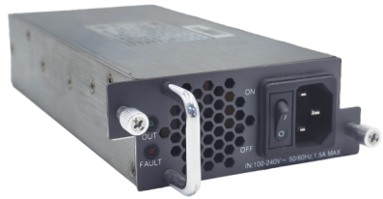

FAN Unit
The switch provides 2 fan unit slots on the rear panel. This plug-in unit internally consists of 2 fans. User can insert fan unit to a fan slot by slowly adjusting them to fit into the slot guid-ance. The air flows from the front side inlet to the rear side outlet.

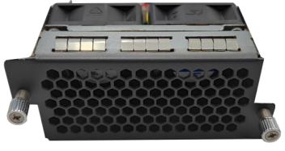

Characteristic | S5863-24X2C
FAN | 8000 RPM adjustable fan

Power Supply Equipment

S5863 has the following power supply equipment:
- Support both -48V DC and 100V AC/220V AC power input.
- Provide over-current and over-voltage protection and noise filtering for DC power input.
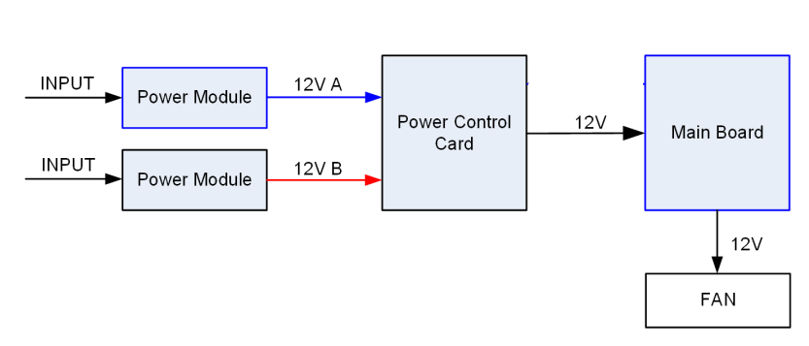

Software Specifications
Attributes | S5863-24X2C
VLAN | Support 4K VLAN  Support VLAN based on port, MAC and protocol  Support dual Tag VLAN,  Access/Trunk/Hybrid
Ethernet | Ethernet interface operating modes  Ethernet interface operating rates  Jumbo Frame  Port enable/disable  Port based storm-control  Unknow-unicast/unknow-multicast/broadcast storm-control  Port-isolate
Stackable | Support Sacking of 8 units through a single ip address.  Support ‌Unified management.‌  Support Redundancy mechanism.  Support High speed interconnect.
VXLAN | Support VXLAN uses MAC in UDP encapsulation  Support VMS can move between different Layer 2 network domains.  ‌Support VNI is used to isolate different virtual networks to ensure that network traffic of different tenants is isolated ‌.  Support Enable virtual machine packets to communicate across different subnets and data centers; ‌
MAC | Support static MAC address setting  Support black hole MAC address filtering  Support port MAC address limit  Automatic learning and aging of MAC addresses
ARP | Static and dynamic ARP entries  Aging of ARP entries  ARP-Proxy
Port Control | Support two-way bandwidth control  Support port storm suppression  Support 9K Jumbo ultra-long frame forwarding
Port Aggregation | Support static link aggregation  Support dynamic LACP  Each aggregation group supports a maximum of 8 ports  LAG load balance（SIP/DIP/SMAC/DMAC）
Mirroring | Supports multi-port mirroring analysis  Service flow-based image analysis
ACL | Support standard and extended ACL  Support ACL policy based on time period  Provide MAC, IP, L4 port and port level security control functions
QoS | Traffic classification based on COS/DSCP (simple classification)  Traffic classification based on ACL (complex classification)  Traffic classification based on inner header of the tunnel packets  Queue scheduling  Remark the priority fields (COS/DSCP) of the packet based on ACL  Traffic policing based on direction(in/out) of Port  Traffic policing based on direction(in/out) of VLAN  Traffic policing based on direction(in/out) of flow  Traffic policing based on direction(in/out) of aggregated flow  SP（Strict Priority）scheduling  WRR（Weighted Round Robin）scheduling  SP + WRR mixed scheduling
Safety | Support user hierarchical management and password protection  Support Radius & TACACS+ authentication  Support MAC address learning limit, support black hole MAC function  Support port isolation  Support broadcast message rate suppression  Support IP Source Guard Support ARP flood suppression and ARP spoofing protection
Layer 3 | Support ARP learning and aging  Support IPv4/IPv6 static route  Support dynamic route RIP/OSPF/BGP  Support IPv4/IPv6 dual-stack platform  Support VRRP、CLI、Telnet、WEB、SNMP V1/V2/V3、SSHv2 mode
Terminal Services | Configurations through CLI  Console Terminal service
Maintenance | Per-module Debug features  CPU usage display and alarm  Memory usage display and alarm  Device temperature、PSU、FAN、status display and alarm  User operation logs  Management of logs, alarms, and debugging information  Manual /Schedule reboot  Reboot Information logging  Ping  IPv6 Ping  Traceroute  Time configuration  Timezone
System Security | SSHv1/v2  RADIUS  TACACS+  Authentication  Accounting  MAC/IP ACL  Port/VLAN/L4-Port ACL  IP Source Guard  Limitation on MAC address learning on interface  Rate limit  CPU Traffic Limit  CLI/WEB/SNMP/Telnet/SSH filtering
Spanning-Tree | Rapid Spanning-Tree Protocol  Multi-instance Spanning-Tree Protocol
Network  Management | DHCP Server  DHCP Relay  DHCP Snooping  DHCP Option60  DHCP Option82  DHCP Option66  DHCP Option120  SNTP Simple Network Time Protocol）  LLDP
Configuration Management | Inband management interface and configuration  Outband management interface and configuration  Privileged user priority and privileged commands  Network management based on SNMPv1/v2c/v3  Public and private MIB  Public and private Trap  Configuration and management based on WEB  Restore factory default configuration
File system | Upload and download files through FTP or TFTP  Upload and download files through Xmodem
System Management | Support FTP, TFTP file upload and download  Support SNTP  Support LLDP neighbor device discovery protocol  Support RFC1213 SNMP network management  Support Ping and Traceroute  Supports configuration management based on WEB pages
Upgrade | Upgrade with the local image file  Upgrade with the remote TFTP server  Online upgrade Uboot

Connector Specifications
The switch provides standardized interfaces, thus facilitating rapid and trouble-free integration into the existing network infrastructures.

Network Interfaces
The switch optical interface ports for SFP/SFP+ modules and below table is available SFP/SFP+ module list.

Index | SFP/SFP+ Module Description
1 | - Wavelength: 850 nm / Distance: 550 m / Mode: multi-mode  - Connector: LC / Data rate: 1.25Gbit/s / Core type: Dual Core  - Operating Temperature: 0 °C - 70 °C
2 | -. Wavelength: 1310nm / Distance: 5km / Mode: single-mode  -. Connector: LC / Data rate: 1.25Gbit/s / Core type: Dual Core  -. Operating Temperature : 0 °C – 70 °C
3 | - Wavelength: 1310 nm / Distance: 10 km / Mode: single-mode  - Connector: LC / Data rate: 1.25 Gbit/s / Core type: Dual Core  - Operating Temperature: 0 °C – 70 °C
4 | - Wavelength: 1310 nm / Distance: 15 km / Mode: single-mode  - Connector: LC / Data rate: 1.25 Gbit/s / Core type: Dual Core  - Operating Temperature: 0 °C – 70 °C
5 | - Wavelength: 1310 nm / Distance: 20 km / Mode: single-mode  - Connector: LC / Data rate: 1.25 Gbit/s / Core type: Dual Core  - Operating Temperature: 0 °C - 70 °C
6 | - Wavelength: 1310 nm / Distance: 40 km / Mode: single-mode  - Connector: LC / Data rate: 1.25 Gbit/s / Core type: Dual Core  - Operating Temperature: 0 °C - 70 °C
7 | - Wavelength: 850nm / Distance: 300m / Mode: Multimode  - Connector: LC / Data rate: 10.3125 Gbit/s / Core type: Dual Core  - Operating Temperature : 0°C ~ 70 °C  - 10GBASE-SR (10G)
8 | - Wavelength: 850nm / Distance: 300m / Mode: Multimode  - Connector: LC / Data rate: 10.3125 Gbit/s / Core type: Dual Core  - Operating Temperature : 0°C ~ 70 °C  - 1000BASE-SX (1G), 10GBASE-SR (10G）
9 | - Wavelength: 1310nm / Distance: 10Km / Mode: Single mode  - Connector: LC / Data rate: 10.3125 Gbit/s / Core type: Dual Core  - Operating Temperature : 0°C ~ 70 °C  - 10GBASE-LR (10G)
10 | - Wavelength: 1550nm / Distance: 40Km / Mode: Single mode  - Connector: LC / Data rate: 10.3125 Gbit/s / Core type: Dual Core  - Operating Temperature : 0°C ~ 70 °C  - 10GBASE-ER (10G)
11 | - Wavelength: 1310nm / Distance: 70Km / Mode: Single mode  - Connector: LC / Data rate: 10.3125 Gbit/s / Core type: Dual Core  - Operating Temperature : 0°C ~ 70 °C  - 10GBASE-ZR (10G）
12 | - Wavelength: 850nm / Distance: 100m / Mode: MMF  - Connector: MMF Data rate: 100 Gbit/s / Core type: Dual Core  - Operating Temperature : 0°C ~ 70 °C  100GBASE-SR4

